# Candidate Information

Name:

Date:

Position you're applying for:

# Rewriting/editing: 30 minutes

# *Rewrite the following paragraphs, so the information is clear, accurate, concise, consistent, and free of grammatical and typographical errors. Feel free to use any formatting, headings, or layouts that you feel are needed to convey the information best.*

In some exceptional cases, the **Paste Special** option is used in Windows when retrieving an image from the Windows clipboard. The Mac clipboard sends the image from the Mac clipboard into an application such as Win95 WordPad, Corel Draw, Canvas, and other applications. The image is in Device Independent Bitmap (DIB) format, and these applications are not DIB compatible.

There are occasions when images may not paste correctly between Mac applications and Windows applications. In many cases, the problem is the type of image format the source application uses and how to pass that format into the destination application. Macintosh and Windows do not support particular design.

The user may take some action to determine which case may be the problem. The following are some things a user may try:

* If the image copies fine to the clipboards (whether Macintosh Clipboard or Windows Clipboard), more than likely. In that case, the problem is with the destination application.
* The destination application may not support the format used by the source application.
* To get the destination application to paste the Clipboard image correctly, the user must use the **Paste Special** option of the destination application. If none of the listed **Paste Special** formats works, the destination application does not support the source format.
* Suppose the destination application does not support the **Paste Special** option; the user may try changing the image format type from the source application.

# Procedure writing: 30-45 minutes

*Write instructions on how to configure notification settings for a user account on the social media platform of your choice. Include screenshots or other graphics as necessary.*

# **Managing Notification settings in LinkedIn**

This procedure provides the instructions to change the notification settings in LinkedIn.

**Note:** This procedure is applicable only for iOS.

To change the notification settings, do the steps that follow:

a) Open the **LinkedIn** app on your mobile device.

b) Tap on the Profile picture. See Figure 1.

**Figure 1:** 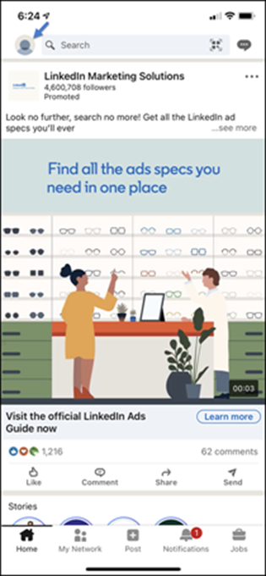

c) Tap the **Settings** in the top right corner of the screen. See Figure 2.

**Figure 2:** 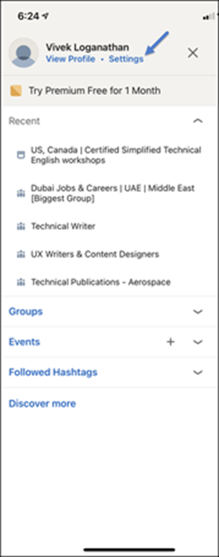

d) Tap the **Communications** tab. See Figure 3.

Figure 3: 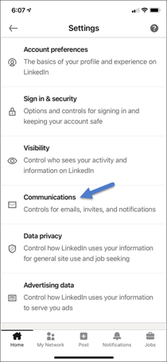

e) Under **How you get your notifications**, tap to select **On LinkedIn**, **Email**, or **Push** to make changes to the notification settings. See Figure 4.

Figure 4: 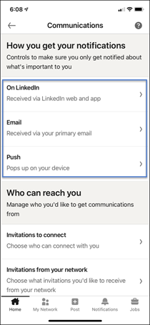

f) You can select or unselect the categories you like to receive notifications by tapping the checkbox next to each type. See Figure 5.

Figure 5: 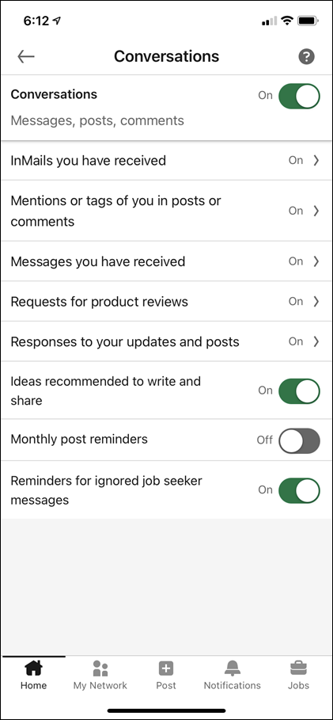

g) Tap on a category to individually select items from within that category.

h) Switch the toggle next to each option you like to receive notifications.

You will either be receiving or stop receiving notifications for a selected category based on the settings.

# Your work: 30 minutes

*Provide a screenshot or link to a recent sample of technical documentation that you wrote. Briefly describe what you are most proud of as well as how you would like to improve it.*